V D M S – I I R e q u i r e m e n t S p e c i f i c a t i o n

SYSTEM
VDMS
SYSTEM REQUIREMENT SPECIFICATION (VDMS-II)

Contents
Requirement for Dealer
1. Home page 5
2. SYM Part Setting 7
3. Search New Part 8
4. Accessory Setting 9
5. Customer Setting 10
6. Category Setting 11
7. Vendor Setting 12
8. Cycle count adjust 14
9. Order part 16
10. Order list & Receive & NG Form 21
11. NG Form Lack status tracking 25
12. Part sales 26
13. <NG> form 28
14. Special import/export 31
15. Stock transfer 32
16. Bin card query 34
17. Close month 35
18. Multi-Level dealer organization management 37
19. Right permission 37
20. Report 38
Requirement for Sales VMEP 44
1. Home page 44
2. Confirm <NG> Form 46
3. NG Form lack tracking 47
4. Undo “Auto Receive” 48
5. Basic Data Setting 50
6. Order date control 50
7. Reports 51

Changed Summary
SEQ | FUNCTION NAME | BEFORE | AFTER | PAGE
1 | Home page | Check receive span by Order, one by one | Check receive span by Issues, one by one | 5
 |  | Message linking: N/A | Message linking (Inbox & Outbox)
 |  | Send/get message is not separated by area, position | Send/get message is separated by area, sub-region and by position (VMEP) | 44
 |  | Auto in-stock: by Order | Auto in-stock: by Issues
2 | Search new part | N/A | New function: List of part which VMEP new issue in one month (default is one month). | 8
3 | Accessory Setting | Accessory code can be same with Part code of SYM | Accessory code cannot same with Part code of SYM (Item master) | 9
4 | Cycle count | Excel upload: N/A | Excel upload function | 14
 |  | Process: Update qty inventory directly  Log data: N/A | New process: Add new qty inventory → Saved → Confirm → Update inventory.  System provide: Comparative list between system inventory and physical qty.
5 | Order parts control | Order date control: N/A | Only send order in the permissed date (setting by gate: Y/N). | 16
 |  | Check re-Order: N/A | Cannot re-Order with the same parts (setting by gate: Y/N)
6 | Order list & Receive | Partial receive: N/A | One order can delivery with many times with difference IssueNo (system provide) | 21
 |  | After In-stock can change receive data | After In-stock or <Send> NG, cannot change receive data and NG data
 |  | Admin action: N/A | Admin user can do all transactions for all sub-store
 |  | Combine with NG form: N/A | Combine with NG form process: Abnormal receive: In-stock and NG form action (make & sent to VMEP) is the same time.
 |  | In-stock exported: N/A | In-stock data can be exported to Excel file
7 | NG Form lack Status tracking | N/A | New function: tracking the NG Form status of return part from VMEP (broken, wrong, lack part).  LACK case: Using the Special import screen  BROKEN & WRONG case: Using in-stock screen | 25
8 | Part sales | Query sale out data: N/A | Query sale out data: System provide | 26
 |  | Sales voucher No: N/A | Sales voucher No: System provide.
 |  | Sales date: One kind | Sale date: two kind: create date & sale out date.
9 | Special Import/Export | History data query: N/A | New screen: History data query: System provide. | 31
 |  | Voucher No: N/A | Voucher No: System provide
10 | Stock transfer | History data query: N/A | New screen: History data query: System provide. | 32
11 | Reports | Export to Excel: N/A | Export to Excel: System provide for all reports. | 38
 |  | Sales report by user: N/A | New report: Sales report by user: System provide
 |  | Monthly report: N/A | New screen: Monthly report: system provide: by sub-store, by parts
12 | NG form confirm | Confirm by region: N/A | Confirm by position, sub-region: System provide (from level 2 can confirm for all) | 46
13 | VMEP’s NG Form lack tracking | N/A | New function: System provide the query lack case from NG form (query by dealer code, NG No, Status (processed or not). User can maintain the status. | 47
14 | Order List & Receive | Add more 2 columns | Delivery Qty, Lack Qty | 24

Home page
  - Brief description:
  - Show messages between dealers and VMEP (information-general: latest news, messages for individual dealer by VMEP)
  - The system displays the today’s notice on the day of payment, receive notice, the list of parts that under the qty of safety stock.
  - Dealers can send / receive messages for VMEP (3 groups: Vehicle, Service, Spare Part) from this screen.
* User cannot send message to multi-division, must select the division first.
  - The system will automatically import the stock dealers if dealers do not import in time to allow.
* Check receive span by Issues, one by one.
  - Notice:
    - This screen is integrated with home page of VDMS-I system (Motorbike Management System): Latest News & Attach File
    - The Outbox is combined with Inbox (add 17.03.09)

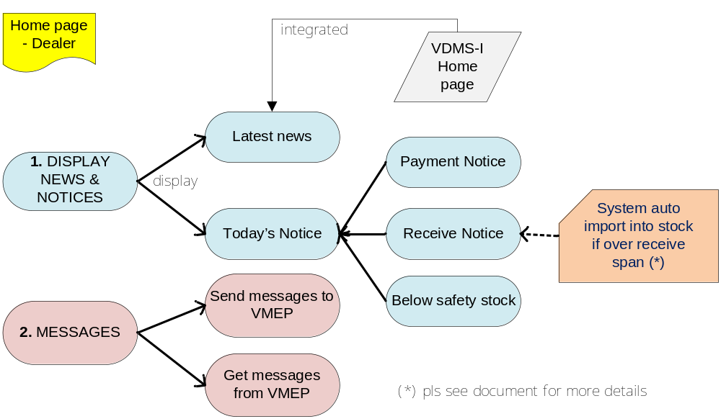

  - Description Requirement:
    - Flow of business:
- The information displayed on the home page:
  - The latest information (integrated with VDMS-I): Show notification of VMEP for all dealers (ex: policies, promotional notice ...), the dealer can download the file attachments if it’s available.
  - Message to dealer: Messages that VMEP send to a specific dealer and the dealer received this, which may be prompted for payment or respond to a specific issue (to be designed as "Inbox"); when send message to VMEP, user attach file (file size < 5MB)
  - Today’s Notice:
    - Notice of payment date (over payment span): If dealers do not pay for VMEP in time to allow (default is 3 days), the system will display a warning about the order in which dealer have not paid.
    - Notice of receiving date (over receive span): After VMEP delivery, in the receive span, dealer must do receive part, otherwise system alert a message (in current day).
    - Notice of parts below safety stock: If the inventory qty of spare parts is less than the qty of safety stock then the system will show up for users to know (remind dealer need to order spare parts for this)
- Send message to VMEP:
  - When send/get message for VMEP, user can select from one of three groups (Vehicle, Service, Spare Part), cannot select multi group, can send/get attach file also.
  - Send/get message is separated by area (south & north) and sub region (by sales man), and by position (ADM, sales-man, staff)
  - System provides multiple objects to send the same time.
  - Message is use for 3 groups:
    - Vehicle (Sales man & ADM)
    - Service (ADM & Staff)
    - Spare part (Sales man & ADM)
  - Relationship between Inbox & Outbox
* Dealer’s sending message to VMEP are stored in the "Outbox”
* Dealer’s receiving messages from VMEP/system are stored in “Inbox”

    - Special Requirement:
- If over receive span, dealer not “do in-stock” parts into the system, system warning in 24h, after 24h over, “do in-stock” still not happened, system automatically import part into the inventory (dealer cannot do in-stock by manual (after auto-receive)).
*With special case, VMEP can undo this “automatically in-stock” action (dealer contact with VMEP), after VMEP undo, the system will check in the next 24h, if the time that dealer are still not import, the system automatically re-instock the stock again (sales can undo auto in-stock with no limit times, after 21 days from payment day, no one can undo in-stock).
- Receive span includes two time periods: Shipping time (time to delivery parts) + check and “do in-stock” time at dealer.
* Shipping span, Receive span are defined by VMEP by each dealer.
- Send/get message is separated by area and can attach file (file size < 5MB).
* Keep Latest new & Messages in two month, today’s notice only in current date.

SYM Part Setting
  - Brief description:
  - Type of parts are:
    - SYM part
    - Accessory
    - Non-SYM part (HONDA, YAMAHA, CHINA)
  - Dealer can maintain: Accessory & Non-SYM part (can maintain all fields)
  - Dealer cannot maintain: SYM parts – get info from Tip-Top (dealer maintains safety stock qty and favorite-rank only, favorite-flag setting at Order screen-add 17.03.09)
  - Part list have two type:
    - For ORDER using list:
      - Using for Order parts with dealer
      - System provide the part list get from Tip-Top by View (always latest part list)
    - For DEALER using list (inventory part list):
      - Using for maintain safety stock, favorite-rank for sales, this list is belong to each dealer.
      - Initial: VMEP provide and upload to VDMS, dealer maintain safety stock, favorite-rank.
      - New part: When dealer key-in “receive order”, system check (compare with inventory part list at VDMS) and automatically update parts into inventory part list.
  - Part’s data fields are: part code, part name, part category, , , specification, unit price, on hand qty, safety stock qty, favorite-rank.
  - Setting favorite flag at Order screen, if part not belong to favorite, can not setting rank in part setting (disabled). Sales favorite is also – add 17.03.09
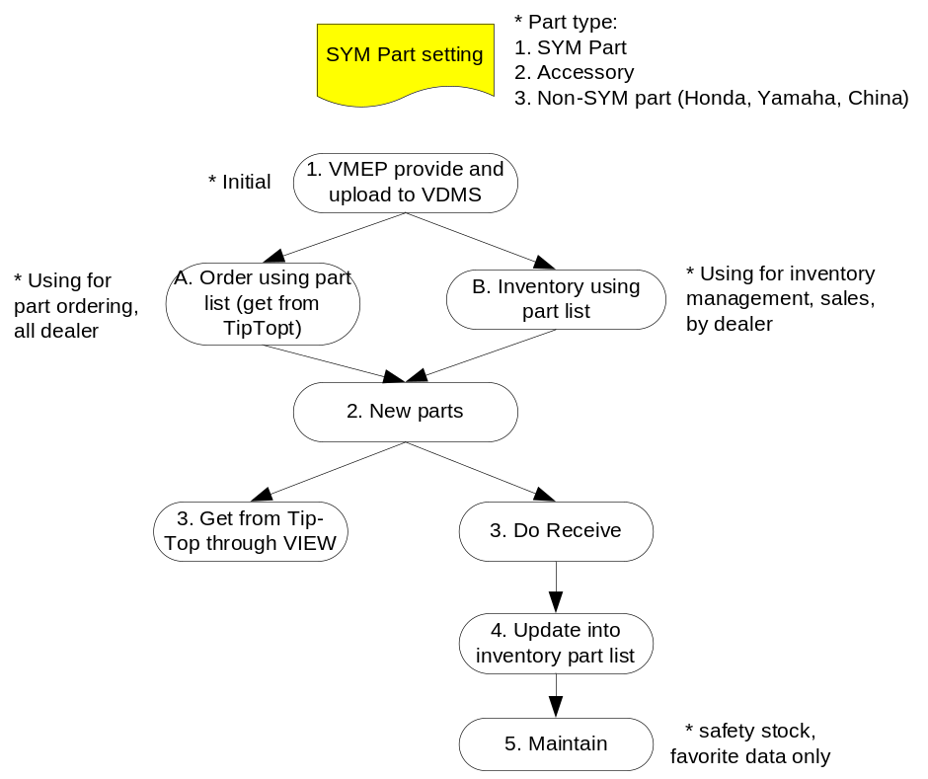

  - Description requirement:
    - Flow of business:
- Search and display information about the parts:
- Users enter the search terms
- If data exist, the system displays information about parts.
- Update qty of safety stock, favorite-rank:
- After the search results display.
- Dealer enter the safety stock, favorite-rank (if need)
- Do “Save”, system record the data.
    - Special requirement:
- When updating the safety stock, qty must >= 0.
- Inventory part list for each dealer is different.
- Favorite rank (option): Defined by dealer.
- System provides dealers with Non-SYM parts information upload function from excel file.

Search New Part
  - Brief description:
  - List of part which VMEP new issue in one month (default is one month) [update: 17.02.09]
  - Description requirement:
    - Flow of business:
- Search and display information about the new parts:
- Users enter the search terms
- If data exist, the system displays information about parts.

Accessory Setting
  - Brief description:
  - List of accessory are maintained by dealer (add, edit, delete)
  - The parts of the non-SYM are grouped in the accessory type.
  - User defines the accessory information: Code, Name, Category, , ,
, Unit Price, Safety stock, On hand, favorite-flag (Y/N value) and favorite-rank.
  - System provides the Excel upload function for accessory list – using by cycle count function-upload function with type=’A’.
  - Accessory code cannot same with Part code of SYM (Item master)

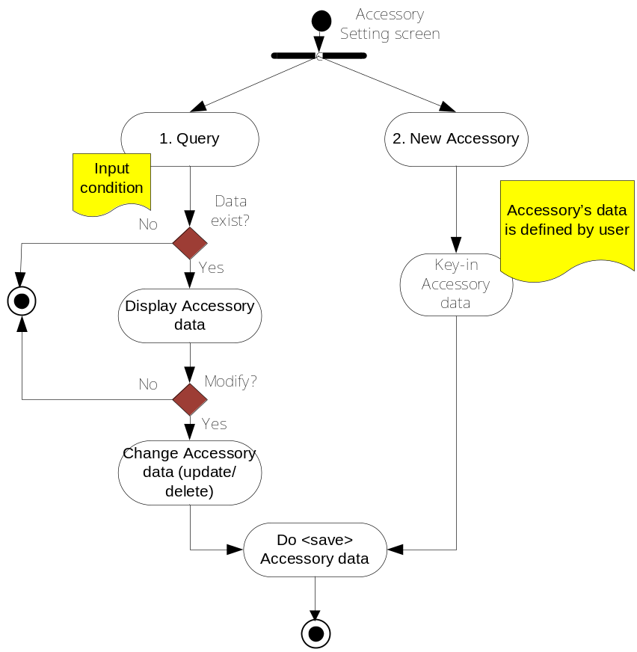
  - Description requirement:
    - Flow of business:
- Search and display information about the accessories:
- Dealer enter the search terms
- If data exist, the system displays information about accessory.
- Add new accessory:
  - Users select <Add new> button , The system displays a screen with information of accessories.
  - Users to enter information of accessories (note: user define all information)
  - Press <Save> at the end.
  - The system recorded information.
- Updated information accessories:
- After the search results display.
- Dealer select accessory and update the information about the accessories.
  - Press <Save> at the end.
- The system recorded information.
    - Special Requirement:
- When updating the safety stock, qty must >= 0.

Customer Setting
  - Brief description:
  - User defines the available customer information for “sale out” function.
  - There are two type of customer:
    - Wholesale/retail customer: is defined with different code by user.
    - Individual customer: is defined with common code by dealer.
  - Dealer maintains the customer data: Code, Name, Full name, Address, Phone, Email, and Remark.
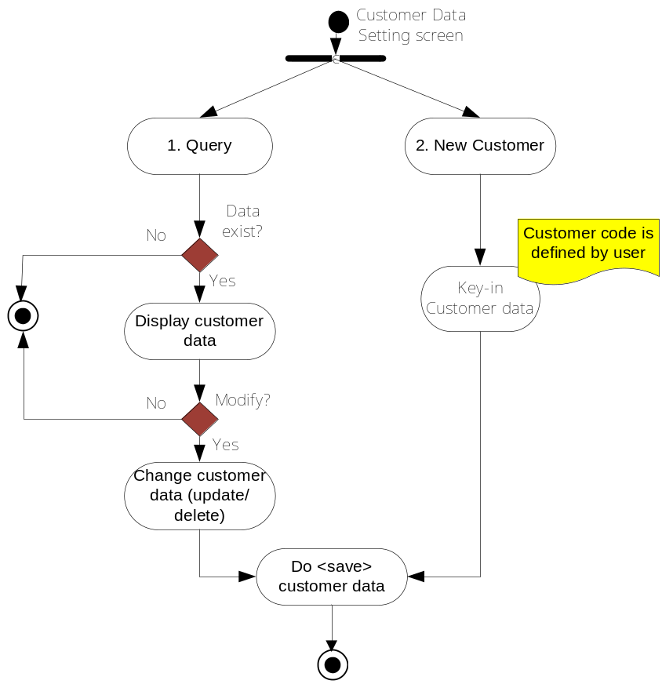
  - Description Requirement:
The system provides functions: add, edit, and delete about customers data.
    - Flow of Business:
- Display customer list:
  - User select <Customer Setting> function
  - Screen displays a list of customers, if the number of customers more than 10 will be assigned pages.
  - Users want to see detailed information by select customers respectively (select <Edit>).
  - The system displays detailed customers data.
- Add new customer data
  - In the display customer lists
  - Users select <Add new>
  - The system displays a screen with information about customers data for the user to enter (note: customers code is defined by user)
  - User select <Save> to record
  - System record the customer data
- Update customer data:
- In the display customer lists
- Users select <Edit>
- The system displays detailed information customers
- Users update the customer data (customer code cannot be changed)
- User select <Save> to record
- System record the customer data
    - Special requirement:
- Customer code cannot be duplicated:
If add new customers which this customer code already exists in the system, then an error message appears "Customers code already exists", the user must be added to a customer code other valid – Customers code can be text, numbers or both.
2. Dealers must input new customer data first before do “sell out” function for a new wholesale customer.

Category Setting
  - Brief description:
  - Category data for SYM parts is gotten from Tip-Top system, dealer do not have the right to change.
  - Category data of accessory parts is maintained by dealers.
  - “SYM Category code”:
  - C (chain), O (oil), P (plug), B (battery), T (tire), S (service).
It is used together with “specification code”:
E (Engine), F (Frame), D (Electricity - Dien), A (Accessory).

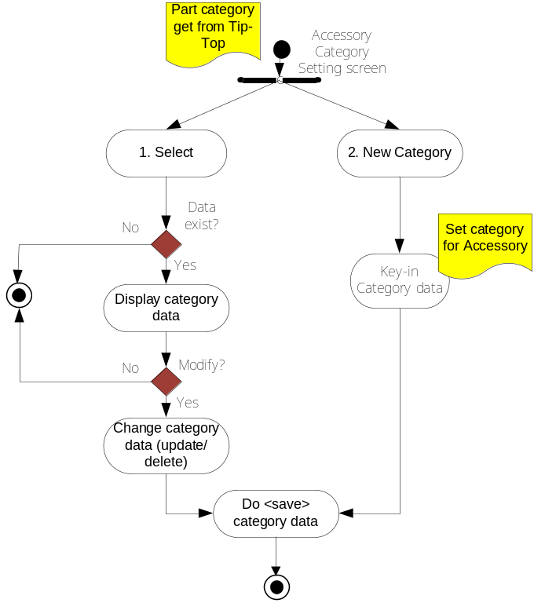

  - Description requirement:
    - Flow of business:
- Display the list of category:
  - User select <Part category> function
  - The system displays a list of category that get from Tip-Top.
  - Users do not have the right to modify this information.
- Add new category for accessory:
  - In the <Add new> screen
  - The system displays a screen with information about empty category to the user to enter
  - User do “Save”
  - System record
    - Special requirement:
* SYM Category codes are used in VMEP internal report,
* About the using details of category code needs to discuss further.

Vendor Setting
- Brief description:
  - Establish the information available vendor of spare part to classify vendor of parts in “LOV” to perform " Special Import / Export"
  - Vendor is separated by code, and information describing the details.
  - The actions add, edit, delete information on vendor like the "Customer Data Setting"
  - The vendor data are: Vendor Code, Vendor Name, Full Name of Vendor, Address, Phone, Email and Remark.
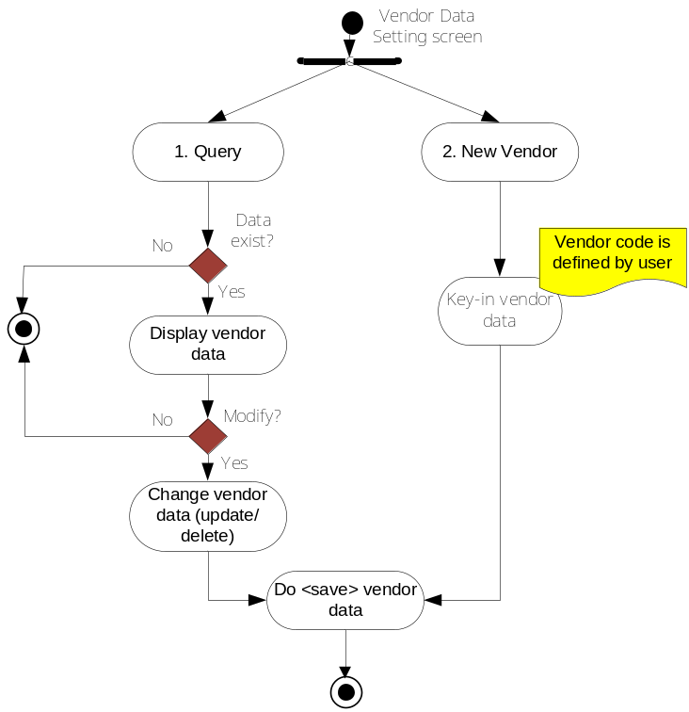

- Description requirement:
The system provides functions: add, edit, and delete vendor data.
- Flow of business:
- Display the list of vendor:
  - Users select the <Add new vendor> function.
  - The system displays detailed information vendor.
  - Users want to see detailed information vendor to choose the respectively vendor (select <Edit> function).
  - The system displays detailed information vendor.
- Add new vendor:
  - In the display list of vendor
  - User select <Add new>
  - The system displays a screen with information about empty vendor for the user to enter (note: Vendor code is defined by user).
  - User do “Save”
  - System record.
- Update vendor’s data
- In the display list of vendor
- Users select vendor to edit the information (select <Edit>)
- The system displays detailed information vendor
- User edit the information (vendor code cannot be changed)
- User do “Save”
- System record
- Special requirement:
1. Vendor’s code cannot be duplicated
2. Vendor code can be text, numbers or both.

Cycle count adjust
- Brief description:
  - Cycle count inventory adjustment.
  - Being excuted yearly accordint to physical cycle count, or when there is a big difference between system inventory and physical count.
  - Adjustment in the balance qty of beginning month yearly. (Adjust all parts for the beginning, don’t care about history data; ex: adjust the qty all part at the end of 2008 year for Jan month of 2009, don’t care about qty of 2008 – [update: 21.02.09])
  - System provides the Excel upload function to adjust the cycle count. [update: 21.02.09]
- Cycle count rule:
  - VMEP IT will set the last close month for the first time before dealers do cycle count.
  - The month before cycle count must be closed (system check). After close cannot do any transaction.
  - User must assign do cycle count in current month (system update beginning qty - warning dealer about this).
- System provides:
  - Comparative list between system inventory and physical qty
  - Confirm cycle count transaction function
  - Log data

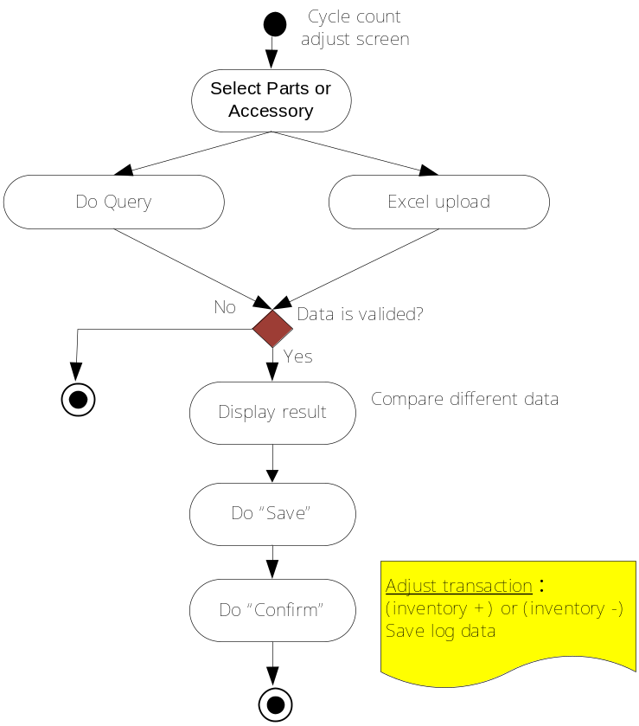

- Description requirement: Part/Accessory inventory adjustment.
- Flow of business:
- Query saved transaction cycle count:
  - Users select the <Cycle count adjust> function
  - Select Saved data
  - Users choose the status: Saved or Confirm
  - User input the condition and perform "search"
  - The system displays results satisfied.
- Inventory Adjust:
  - Online mode:
    - Input part data info (part select method like order screen)
    - Key in new inventory qty
    - System provide the comparative list between system inventory and physical qty.
    - Do Save.
  - Excel upload:
    - Input the part data into excel template.
    - Using upload function.
    - Do upload
    - System check valid data and provide the comparative list between system inventory and physical qty.
    - Do Save.
  - Do confirm:
    - In the confirm tab
    - Query and select saved transaction
    - Do confirm
    - System update the new inventory qty.
- Special requirement:
1. After adjust the qty, user will not using the past inventory data, only calculate from new beginning [update: 21.02.09]
2. About casual inventory adjustment function in the open month is reserved and need to discuss further.

Order part
- Brief description:
  - Allow dealer order parts from VMEP.
  - Order methods :
    - Offline mode:
      - Excel file upload
    - Online mode:
      - Select mode
        - Select part code
        - Select my favorite
        - Select safety stock
      - Page mode
      - Key-in and save by page
  - Sending orders for VMEP need two actions:
    - Save Order
    - Check, confirm (dealer’s internal) and send to VMEP
- Functions: <Query>, <Add new>, <Update> function is set right permission by dealer
- After VMEP do quotation, dealer cannot change (update/delete) the content of Order.
  - Orders data are synchronized between VDMS & Tip-Top.
* SYM drawing & engineering change is reserved, not using now
* Order form can be printed.
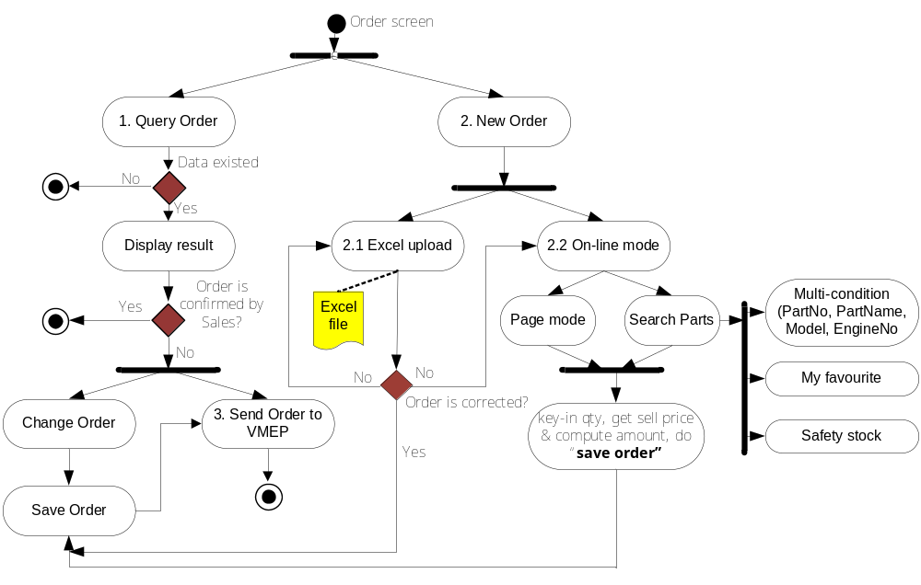
- Description requirement:
- Flow of business:
- Query & display order:
  - Users select the function <Orders part>
  - The system displays a blank screen with the conditions on the search.
  - Do “Search”
  - System display search result
* System need show indicator for manual order and order created by Tiptop
  - Note:
    - Order status is defined like below:
      - Open (OP): is default when dealer create new order and saved
      - Sent (SN): Order is sent to VMEP
      - Confirmed (CF): Order is confirmed by VMEP
      - Closed (normally) (NC):
* Quote Qty = Issues Qty (normal receive) (some order can be never close -> it’s OK)
* After sent <NG> (abnormal receive)
* When broken and wrong case happens and <NG> form is confirmed, then a new order is created in Tip-Top as soon as VMEP make a sales voucher for exchange (this order was automatically synchronized with VDMS).
    - Order type:
      - Normal order: Orders are created when dealer sent to VMEP.
      - Sub-Order: Order which the system automatically created as soon as VMEP delivery the part to dealer (send message to dealer to notify). If VMEP’s delivery-qty is less than dealer’s order-qty.
- Add new order part:
  - In screen <Orders part>, users select <Add new> functions.
  - The system displays a screen to add new orders.
  - To create a new order there are two ways:
    - Online mode
    - Excel upload (off-line mode)
  - The first way: Create order online (select parts, and key-in by page mode)
    - Users select the location of delivery
    - Order date: Default is on the current
    - Order type: Default is normal
    - Select part: System provide 4 methods to select parts and added to Order
      - Method 1: Select parts information
(parts code, parts name, Eng-no, and model)
        - Users can search by many different criteria (or a combination of many conditions) as: Part code (type a minimum of 5 characters), parts name (English & Vietnamese), engine no (must input the full number of engines), Model (selected from a list of available models of VMEP).
* EngineNo is combined with Model: When user key-in EngineNo, press <Get model> button, the model list return the model correspond with EngineNo. PartNo is combined same with EngineNo, return the model which part is belong to. (add 17.03.09)
        - After input the search term, do “Search”, the system displays a list of parts that meet the condition (users can add parts from this list to "My Favorite" by built-in star, then parts will be add to the list "My Favorite").
        - Users select the part by click on the corresponding parts (can select multiple parts at once)
        - Click <Save>, the system will add details of the Order with the parts that users have chosen.
      - Method 2: Select “My favorite”
        - Users select the "My Favorite", the system displays a list of parts in rank sequence that users often order (the dealer can customize this list needs), users can add search conditions in this screen to results over short (e.g. search by code, name)
        - Users select the part by click on the corresponding parts (can select multiple parts at once)
        - Click <Save>, the system will add details of the Order with the parts that users have chosen.
      - Method 3: Select “Safety stock”
        - Users select the "Safety Stock", the system displays a list of part that the amount of inventory below the safety stock
        - Users select the part by click on the corresponding parts (can select multiple parts at once)
        - Click <Save>, the system will add details of the Order with the parts that users have chosen.
      - Method 4: (page mode): Users enter part inform directly into the screen (edit and save by page)
        - Users more line order detail on the screen (5 or 10 more lines out 1 times)
        - Users enter part information directly into the screen (part code, quantity).
    - After dealer finished select the parts, users perform <Save> Order. The system will check the correct data and record information into the system (Order in the state "saved" in-store dealer, not send to VMEP).
  - The second way: Create order offline (Excel upload)
*User input orders data into the Excel file (template provided by VMEP
as below)
Order line | Part No | Quantity | Model
1 | 1220A-A1A-0001 | 30 | VT1
2 | 1220A-A1A-0002 | 50 | VT2
3 | 1220A-A1A-0003 | 90 | VT4
4 | 1220A-A1A-0004 | 4 | VT7

    - Select <Upload file Excel Order>
    - Browse the Excel path
    - Select <Upload>
    - The system will read the information from Excel files and make on the content Order.
    - If there is any line error, the system will alert users and user update the Excel files, upload again or edit directly on the screen.
    - After dealer finished upload Excel file, users perform <Save> Order. The system will check the correct data and record information into the system (Order in the state "saved" in-store dealer, not send to VMEP).
Notice:
      - Data in four columns as in the sample Excel files must be entered.
      - The model data is used to check more of the correct part code.
- Send Order to VMEP:
  - Send order with normal type:
    - In results of the search screen order (search for order status saved)
    - Users select orders should send VMEP
    - Do “Send”.
    - The system sent the order has been selected for VMEP
  - Send order with sub-order type:
    - In results of the search screen order (search for order type is sub-order)
    - Users select orders should send VMEP
    - Do “Send”.
    - The system sent the order to VMEP for confirmation (users cannot edit/delete sub-order content)
- Update Order:
  - Note: Order can only be modified in the status "save" and "Sent to VMEP" (ex: before VMEP quote), after VMEP has a quote (confirmed) and the dealer cannot change the content of order, if there needs to change dealer will contact with VMEP.
  - In results of the search screen order (search for order status saved or sent to VMEP)
  - Users select the order to change the content (can change all information on order)
  - After the change the information, users do “Save”
  - The system updates the information of order (the order is still stored at the dealer)
  - Dealer send order same with step 3 and then this information will be updated on the old order that had been to VMEP.
  - Status of orders that may be changed, as the summarize as table below:

Order Status | Dealer Modify | VMEP Modify | Remark
Dealer saved | √ | X | Modify in VDMS
Sent – Before VMEP quotation | √ | X | Modify in Interface file
Sent – After VMEP quotation | X | √ | Modify in Tip-Top.
Sent – After VMEP confirm payment | X | X

- Special requirement:
- Order qty must be > 0.
- Sub-Order is automatically created when VMEP has deliveried the parts to dealer. Sub-Order cannot be modified by dealer. when sending this orders to VMEP, if it has been confirmed by VMEP and VMEP still has not enough inventory to supply dealer, then the system will continue to create another new sub-order if the sub-order delivery-qty is still less than order-qty when the sub-order payment is confirmed.
- When VDMS make order, the STOP parts will be disappeared. If part dealer key-in have replacing parts, VDMS will show the button to query the replacing parts and then dealer can select the part replace for STOP part. The list of replacing part, PC3 (stock controler department) will import or update to VDMS system from excel file
- When user upload Excel file, if the content of any line is not valid then the line orders will be changed to red to alert the user know. When the user updates the content of Excel files and uploads again or edit orders directly on the screen.
- For the part parking with Box, Set… (for examble: Oil, gasket, Bugi…), If quantity of dealer request do not enough a Box, Set, VDMS will round up to next unit of Box, Set.
- System needs an indicator to distinguish normal order (created by dealer) and abnormal order (created by VMEP, in Tiptop).
- With <Query>, <Save Order>, <Send Order to VMEP> functions, the user set right permission by themselves.
- With non-normal type order (promotions, discounts ...) that are created by VMEP will also be passed back to VDMS side.
- Order control:
  - Send Order in the permissed date.
  - Re-Order same part in the next Order and provide a gate to control (on/off) (2009.08.18-Added)
    - Conclusion: When send order, check all parts in the order which is not include in the list not yet quotation, cannot send.

Order list & Receive & NG Form
- Brief description:
  - Display a list of orders that had been confirmed and shipped by VMEP
  - Do “Import part into stock”
  - Record the abnormal receive case (wrong, lack and broken part)
  - Partial Receive: One order can delivery with many times with difference Issue-No (sub-order is same)
  - Policy: One Order, One Issues, but system has multi issue function (future using)
* Remove policy: One Issues multi Order
  - After confirm “do in stock” and send NG form, the in-stock & NG data cannot be changed in any case.
  - Admin user can do all transactions for all sub-store
  - In-stock data can be exported to Excel file
  - “Do in-stock”:
    - Normal receives: After do in-stock, the receive data cannot be change in any case.
    - With Order type is Part return (for BROKEN & WRONG case) then:
      - User cannot change in-stock good qty.
      - After do in-stock, system move to NG Form lack tracking function, user update (refer to NG Form lack tracking function)
    - Abnormal receive: Combine with NG Form process
      - After in-stock, if abnormal case happens, change to NG form. In NG form:
        - If press <Back> button back to receive screen; can change receive data
        - After In-stock or <Send> NG, cannot change receive data and NG data.
        - If user click <Cancel> button, system warning and NOT update the receive data and NG data into Database.
* Adjust function will discuss later

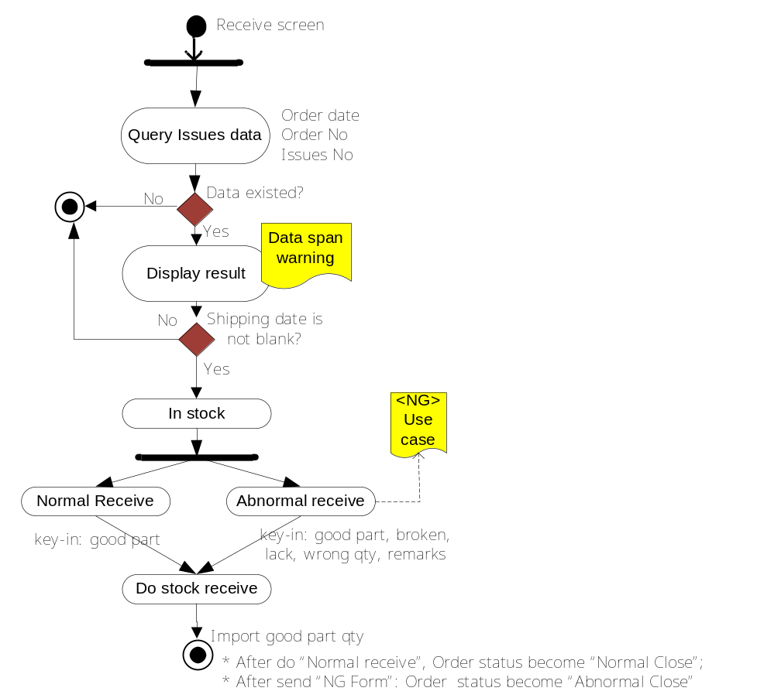
- Description requirement:
- Flow of requirement:
- Search and display a list of orders
  - Users select screen <Order list & Receive>
  - The system display screen search Order
  - Users enter search terms
  - The system displays search results
- Do “In-Stock”:
  - Pre-condition: In the search result, <Shipping date> is not blank.
  - In the search results screen, if < Shipping date > is not empty, the user can perform receive spare parts to the inventory.
  - User select <In Stock>
  - The system displays a screen for the implementation of import:
    - The default qty of import spare parts inventory is the same with VMEP’s quote-qty.
    - If the actual received qty of parts are less than the quote-qty then the user enter the actual qty received in the column "good" and fill in the missing quantities in "Lack" column
    - If the abnormal receiving case happens (broken or wrong) then dealer use the two columns to "Broken," "Wrong" to record.
    - The formula check valid is like that:
      - Quotation Qty = Good Qty+ Broken Qty + Wrong Qty + Lack Qty
* The Qty in stock = Good Qty. [update: conclusion at monthly meeting 19.02.2009]
* If abnormal case is happened then the remark is required.
  - After recording the information about to import, users perform "Import", the system recorded the quantities of import and abnormal of cases: broken, wrong, lack.
- Special requirement:
- If in search result screen, the <Shipping Date> is blank then the “Import stock” function is disabled.
- Combine with NG form process:
  - After in-stock, if abnormal case happens, change to NG form. In NG form:
    - If press <Back> button back to receive screen; can change receive data
    - Do confirm, system do both: in-stock and send NG form to VMEP.
  - After In-stock or <Send> NG, cannot change receive data and NG data.
- Admin user can do all transactions for all sub-store
- “Order List & Receive” screen is also used to query all order information and status.
- “Order List & Receive” screen add more two columns: Delivery Qty, Lack Qty
- TIPTOP should update on Interface as Order Qty =Quotation Qty,
VDMS add 2 column and calculate: Lack Qty = Quotation Qty - Delivery Qty
- If Quote Qty = Issues Qty (normal receive) or After sent <NG> (abnormal receive) mean order is close.

NG Form Lack status tracking
- Brief description:
  - When Abnormal receive (broken, wrong, lack parts) or Part return (warranty case), dealer send NG form to VMEP, system provide this funtion to tracking the NG form status: Which NG is done, which is lack, and what is status. User can update the status of each part for every NG Form.
- Process:
  - AMATA fill the NG No on the manual issues voucher
  - LACK case: Using the Special import screen
    - Dealer key in the Part Info (Part No, Qty…)
    - Select Part return type (Normal/Part return – Normal is default)
    - If Part return case, Key in NG No
    - Press Save (save data and move to NG form edit screen)
    - System move to NG form screen:
      - Update:
        - Return Lack Qty (lack qty updatable only, other fields is locked)
        - Remark content
        - Status (check box control): check means passed
        - Save
  - BROKEN & WRONG case: Using in-stock screen
    - Tip-Top provide the NG No (keep in the interface file)
    - Dealer go to the In-stock screen:
      - Do in-stock
      - Cannot key-in abnormal fields
    - Move to NG form screen:
      - Update:
        - Return Broken & Wrong Qty (broken & wrong qty updatable only, other fields is locked)
        - Remark content
        - Status (check box control): check means passed
          - Save
          - Check NGNo in interface file

- NG Form lack tracking layout:
PartNo | Shipped | Good | Broken | Return Broken | Wrong | Re-Wrong | Lack | Re-Lack | Passed status | Remark
Part A | 30 | 25 | 2 | 0 | 3 | 0 | 0 | 0 | CheckBox Type | XXXXX
Part B | 40 | 20 | 10 | 0 | 0 | 0 | 10 | 0
Part C | 50 | 45 | 0 | 0 | 0 | 0 | 5 | 0 | 0

- Insert one more interface table for update NG No: (updated 12.06.09)
  - When VMEP level 3 approve NG form then send Issues No and NG No into Interface file, Tip-Top will get to process.
  - When VMEP return part by new order still provide NG No in interface file (TC_VDR file).

Part sales
- Brief description:
  - Sell part/accessories for wholesale/retail or individual customer.
  - System provide the “SAVE” and “SELL OUT” status of sales data [update: 21.02.09]:
    - When “Save”: temporary saving data, user can modify sales data and then “sell out”.
    - When “Sell out”: user query sales data again and do “sale out”, user cannot modify sales data after “sell out”.
      - Cannot sale out if sale qty > in hand qty
  - System provide sale voucher number (temporary & formal number)
    - Temporary sale voucher number: User key in by manual (cannot duplicate)
    - Formal sale voucher number: Created by system when sale out
  - System provide two kind of sale date:
    - Create date
    - Voucher date (Sale out date)
  - System provide query Sale out data

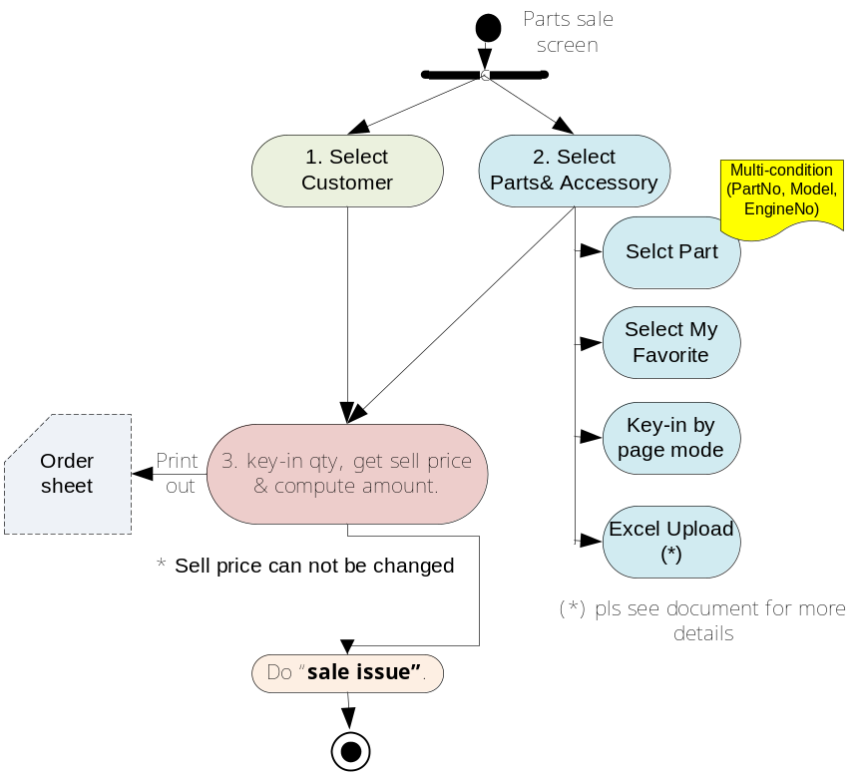
- Description Requirement:
    - Flow of business:
- Select part/accessory:
  - The sales parts search/display mode is like the Order screen:
    - Search mode (multi-condition: part no, part name, engine no, model)
    - Select from “My favorite”
    - Selling quantity must be smaller than or equal to Available stock
    - Key-in (page mode)
    - Upload Excel file: part list from Excel (Excel layout like as below)

SEQ | PART NO | QTY | DISCOUNT
1 | 11394-M3B-000 | 1 | 10%
2 | 11394-M3B-001 | 4 | 12%
3 | 11394-M3B-002 | 5 | 10%
4 | 11394-M3B-003 | 12 | 5%

    - Note:
      - Can search for spare parts or accessories
      - The system provides print out Order Sheet function.
  - Customer information select from a list of clients available-“LOV” (selected by the customer code) - customer information is optional, not mandatory.
  - After selection of part/accessory and customer information. There are two options for user:
    - Do “SAVE”: temporary save sales data, can query again and do “sell out” later.
    - Do “SELL OUT”: immediately save sales data, after “sell out” user cannot modify data
- Do “SAVE” the sales data: “Part/Accessory”
  - Users enter the qty, information discounts and implement "SAVE”.
  - The system temporary records the transaction sales with “saved” status.
- Do “SELL OUT”:
  - User query and select the sales data with “saved” status
  - Select the data
  - Do “sell out”, at this times the sales data is saved into DB and after that, user cannot modify the sales data.
    - Special requirement:
- User cannot change the unit price of SYM part, except the unit price of accessory.
- When user upload Excel file, if the content of any line is not valid then the line will be changed to red to alert the user know. When the user updates the content of Excel files and uploads again or edit directly on the screen.

<NG> form
- Brief description:
  - Send the issues to VMEP in cases:
    - Abnormal case (broken, wrong, lack part) – Combine with Order list and receive function.
    - Return part to VMEP (optional function – reserved for future use)
  - VMEP provide layout of <NG> form

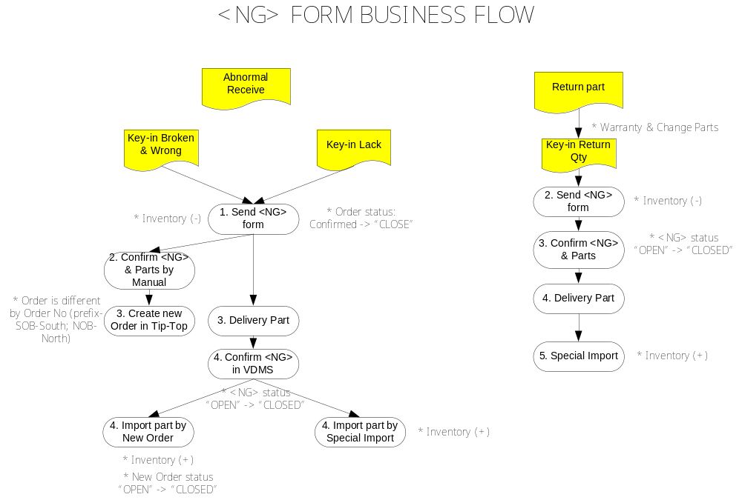

- Description requirement:
- Flow of business:
- Search and display the <NG> form:
  - User select <NG form> function
  - The system displays the screen with search terms.
  - Users enter their search terms
  - Do “Search”
  - The system displays search results
  - Users can view details of <NG> form by selecting function <Edit>
Note: The system will search and display both <NG> form for both two cases: Abnormal receive and Return part.
- Make new <NG> Form:
  - <NG> form has two types:
    - <NG> form for abnormal receive
    - <NG> form for return part
  - Make new <NG> form for Abnormal receive (data has been recorded when “do receive” parts): Combine with Part receive function (abnormal receive), please refer to this function.
  - Make new <NG> form in “Return part” case (data is input by manual):
    - Users choose <Make NG form by manual>
    - The system displays search screen to select the parts and input complete information to form.
    - User select parts (the same way in Order screen):
      - Search by multi-condition (part code, part name, engine no, model)
      - Key-in page mode
    - After selecting parts, users enter the quantities and notes.
    - Do “Save” <NG> form
    - System record
- Send <NG> form to VMEP
  - In search results screen
  - Users select <NG> form which they want to send to VMEP.
  - Do “Send”
  - The system sent <NG> form to VMEP to process (minus the inventory dealer)
  - When sending to VMEP the <NG> form, the system also sends a message to VMEP to inform about this.
- Special requirement:
- One <NG> form is grouped and sent for one Order.
- For <Query> and <Send> function, dealer can use it (separated or mixed) by permission setting.
- Like in the case of order, if VMEP not yet confirm the <NG> form, the dealer has the right to change the information after you sent. If VMEP confirmed, the dealer are not authorized to edit this information anymore.
- In the case of broken and wrong part when VMEP delivery part to dealer, a new order which was created by VMEP in Tip-Top and this order will be post back to VDMS side to track, dealer import and close new order as normal receive when VMEP delivery part. If Quote Qty = Issues Qty (normal receive) or after sent <NG> (abnormal receive) mean order is close.
- In the case of return part/lack-qty, when VMEP delivery without issues paper then the dealer use special import functions to do in stock.
- The <NG> form number is creating by system follow format:
  - NG+yy+mm+dd+seq No (4 byte) + Dealer code (for manual case)
  - IssueNo + ‘NG’ (for Abnormal receive)
- After VMEP confirm the <NG>, this <NG> form is closed

Special import/export
- Brief description:
  - Special import: User use in case:
    - Return part from VMEP or
    - Import part from other vendor (ex: other dealer)
  - Special Export: User use for accessory and the warranty part with customer.
  - System provide history data query
  - System provide Voucher No

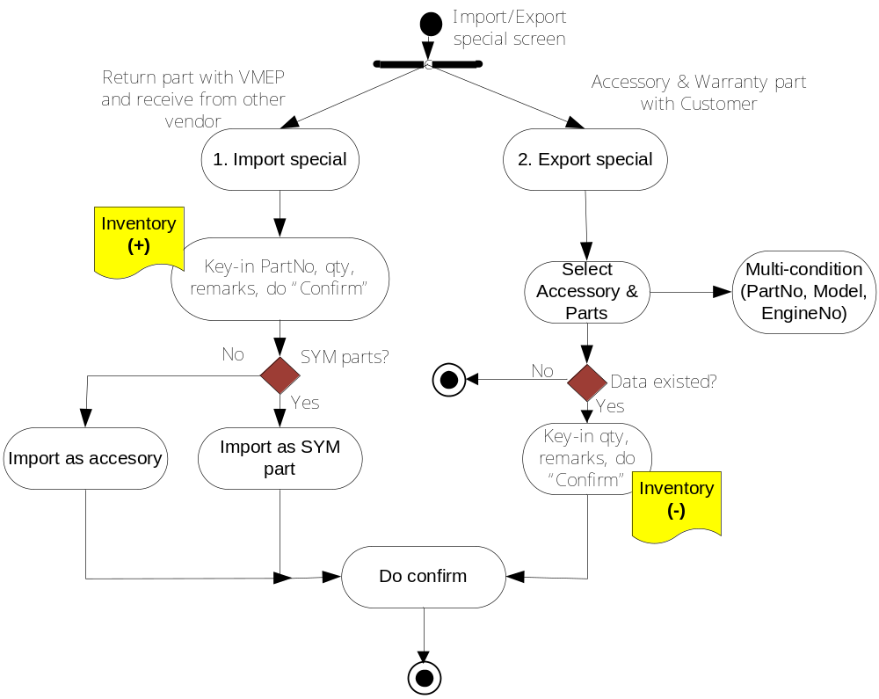
- Description requirement:
- Flow of business:
- Special import:
  - User select <Special import> function
  - System display the <Special import> screen
  - User key-in the part’s info on the screen, can select the different vendor from combo Box
  - Input remark if need
  - Do “Import”
  - System check valid of part code, qty and plus the inventory
- Special Export:
  - User select <Special Export>
  - Select the parts: the way is the same with Make new Order screen
    - Search by multi-condition (part code, part name, engine no, model)
(Accessory parts have not engine-no & model options)
    - Key-in on the screen (page mode)
  - Do “Special Export”
  - System minus the inventory
- Special requirement:
- Special import/export functions are served to dealers for their internal inventory management, and it is not belong to VMEP’s management requirement.
- System provide history data query.
- System provides the Voucher No.

Stock transfer
- Brief description:
- Parts transfer between dealers and sub stores
- System provide history data query

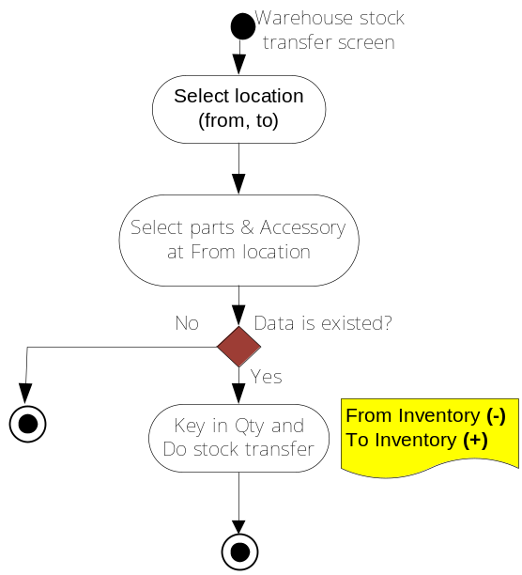
- Description requirement:
- Flow of business:
- Stock transfer:
  - User select <Stock transfer>
  - System display <Stock transfer>
  - User select the source and destination store to transfer
  - Select part:
- Method 1: Select parts information
      - Users can search by many different condition (or a combination of several conditions) such as: part code (type minimum 5 characters), part name (English & Vietnamese), the number of engine (must type the full number of engines), Model (select from the list of available models of VMEP)
      - After put into the search, select <Query>, the system displays a list of components that meet the search.
      - Users select parts by click on the corresponding part (can select multiple part at once)
- Method 2: (page mode): Users enter directly part info on the screen.
      - Users additional line information desired part on the screen (5 or 10 lines of detail)
      - Users enter information directly in the screen (part code, quantity).
  - After user fill in the information parts / accessories, users perform "Confirm", the system will perform the transfer of part from warehouse to warehouse source destination (a stock plus, a stock minus)
- Special requirement:
- About transfer permission setting and transactions confirmation between From/To stores needs to discuss further with dealers.
- System provide history data query.

Bin card query
- Brief description:
- Query the in/out transaction history of individual part (user must key-in full part number; [update: 19.02.09-monthly meeting])
- Compute the current balance (from beginning date balance)
- System provide bin card query across different month
- Query limitation is within 3 months (default is from beginning date of current open month)
- When close month, must display the begin qty of all parts in the current month (add 25.03.09)

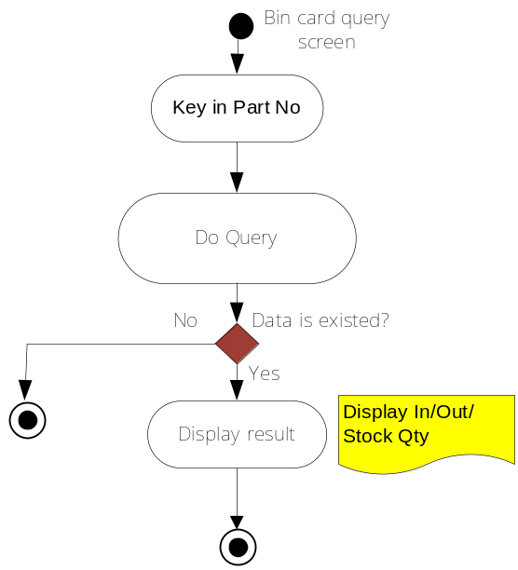
- Description requirement:
- Flow of requirement:
- Query:
  - User select <Bin card query> function
  - System display < Bin card query >
  - User input term condition
  - Do “Query”
  - System display the history “In/Out” of part/accessory
- Special requirement:
- System provide bin card query across different month
(ie. Default of the beginning date is the first date of the current month; But Dealers can also select the date in the past month, so system must calculate the beginning date’s balance dynamically.)
- Query limitation in 3 months
- System provides Dealers with “monthly close report” for all store parts’ transaction history and end-date balance. Bin card query is used for only individual parts.

Close month
- Brief description:
- Keep the status of the parts in the current month to make statistics and calculate the amount of inventory last month.
- System provides the re-open function.

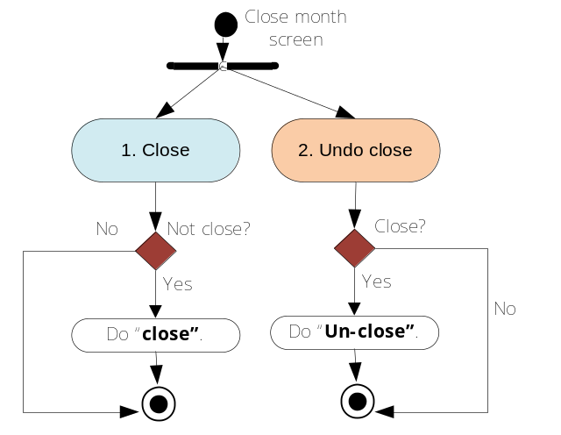
- Description requirement:
- Flow of business:
- Do “Close”:
  - User select <Close Month>
  - System display screen
  - User selects the month to close.
  - Do “close”
  - System “do close” – user cannot do any action (in/out) in the closed month
  - Note:
    - If the main dealer already “closed” inventory then sub dealer cannot do anything in closed month.
- Special requirement:
- If the main dealer already “closed” inventory then sub dealer cannot do anything in closed month. Otherwise using re-open function
- Sequence close:
a. Close sequence is from bottom to up, That is from sub-store to comp-dealer, and from comp-dealer to main dealer.
b. Users do “monthly close” base on the principles sequence (the lock in sequence, also open in sequence). If user does wrong the system reporting errors.
- When do “re-open”:
  - Dealer cannot change receive data only (for SYM)
  - Can only re-open in two months before

Multi-Level dealer organization management

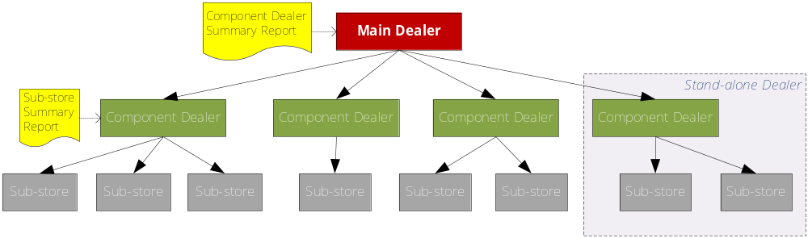
1. VDMS-II system provides multi-level dealer’s organization relation's definition (parent and child relation).
2. VDMS-II system provides report management for multi-org dealers:
a. Main dealer has summary reports for all sub-dealers.
b. Sub-dealer has summary reports for all Sub-stores.
c. Sub-stores have individual reports.

Right permission

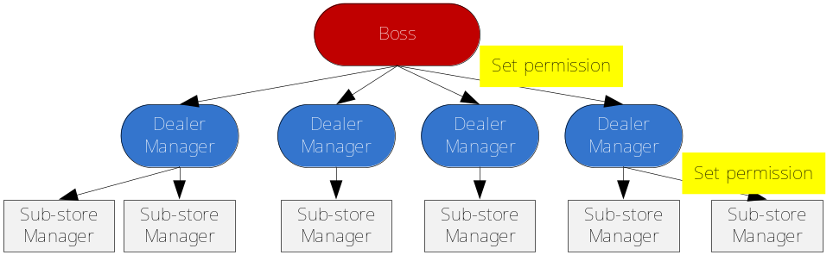

- Role Management:
  - Each dealer has one and only one Administrator role, and the other role must be the child role.
  - The system allows users to edit and delete user in the role as needed.
- User Management:
  - A user in the system can be in many roles.
  - The main dealer setting right to sub-dealer and sub-dealer setting right to sub-store
- Data access permission:
  - Dealer: in this group, user can access to the data of this dealer and the dealers which be direct child;
  - Sub-store: in this group, user can access only the data of this sub-store

Report
Convert all reports to grid form, no longer use Crystal Report.
- Part input report
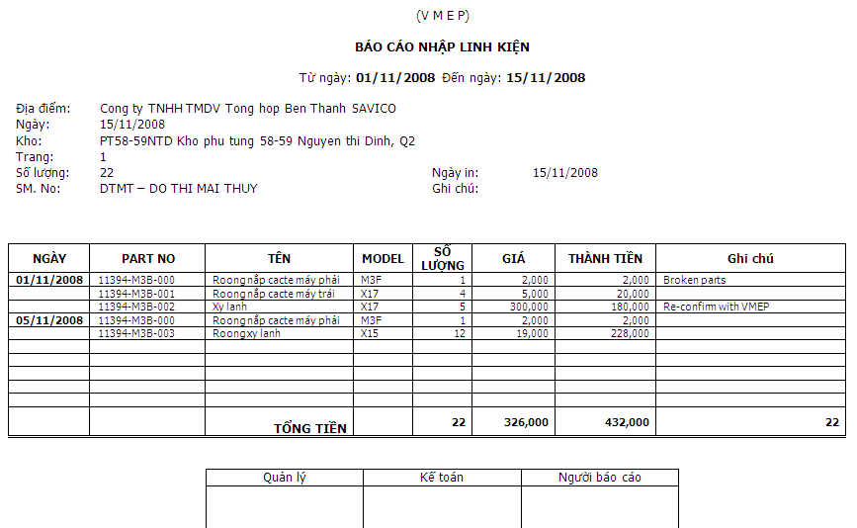

- Input/Sales stock report
- Add more monthly type: I/O stock report, divide by Organization of dealer (export to Excel) (add 25.03.09)

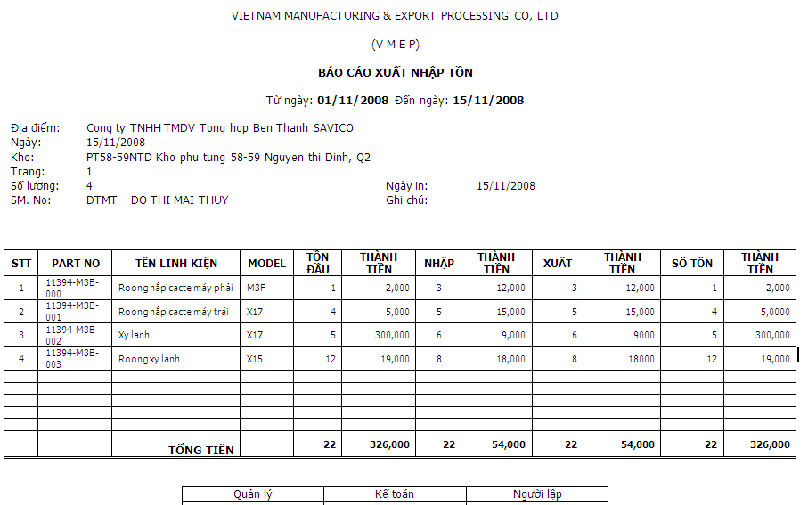

- Order Sheet

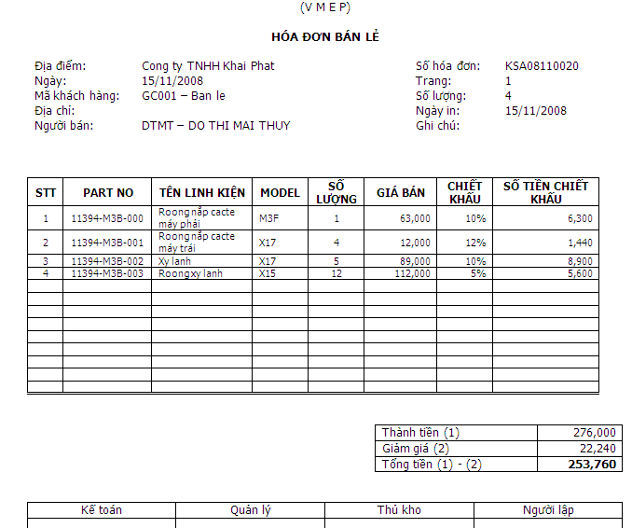

- Internal transfer sheet
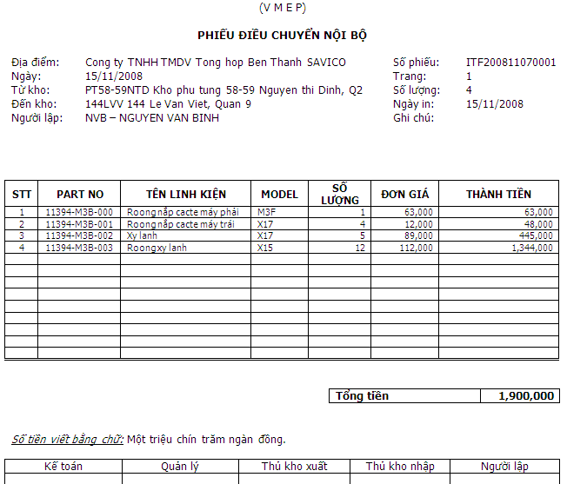

- Sales detail report
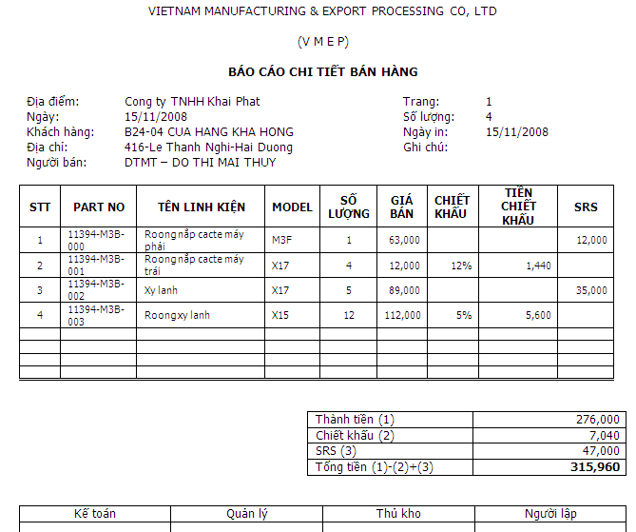
- Sales detail report (by customer)
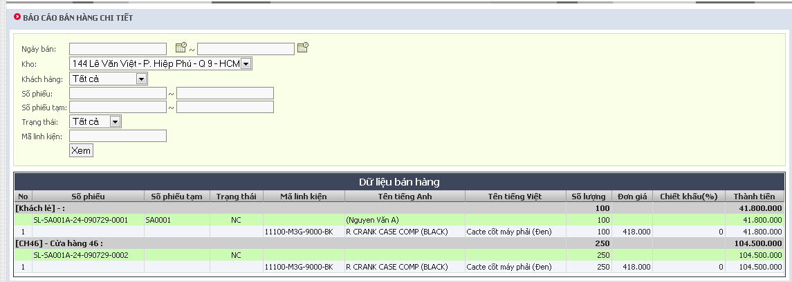

- In short supply report
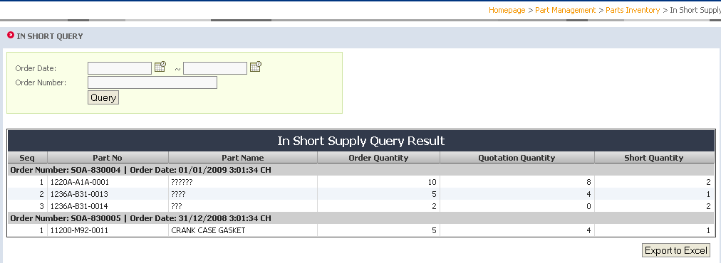

- Remaining Order Report
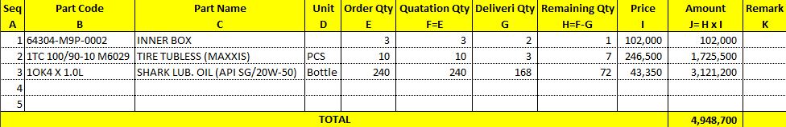

Requirement for Sales VMEP

Home page
  - Brief description:
- Integrate with home page of VDMS-I
- Platform for announcing VMEP’s public news to all dealers
- Platform for exchange messages between individual dealer and VMEP by sending & receiving functions
- Display system notice to dealers with over payment & receiving span, and with parts under safety stock
- System gives warning in 24 hrs after over receive span, and automatically import parts to stock if dealer do not do receiving after 24 hrs warning time.
- System sends message to sales man if over shipping span or quotation span (for sales VMEP)
- Main messaging function spec:
a. System provides multiple objects to send the same time.
b. Message to VMEP is separated into 3 groups: vehicle, service and Spare Part.
c. Each group is separated by area (south & north), sub region (by sales man) and by position (ADM, sales-man, staff)
d. System provides message linking function by recording msg. no.(for VMEP).
e. System display the reply status of message at the Inbox (anwser message or not) [update: 21.02.09]

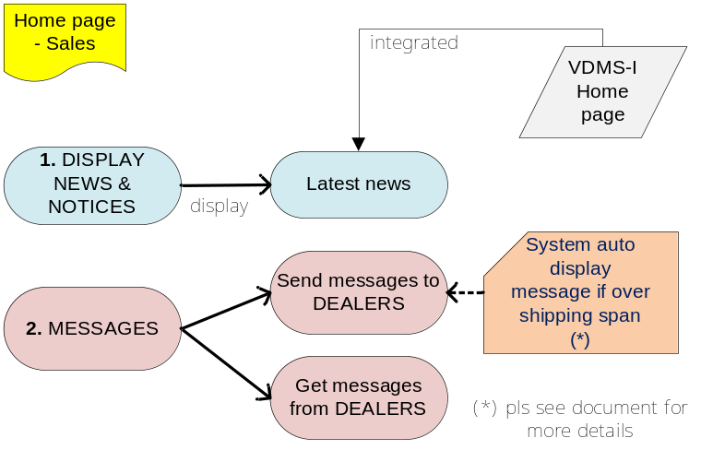

  - Description Requirement:
- Flow of business:
- The information displayed on the home page:
- The latest news (integrated with VDMS-I): Show notification of VMEP for all dealer (ex: policies, promotional notice ...), the dealer can download the file attachment if available.
- Messages sent from dealer to VMEP: Messages that dealer send to VMEP; if the number of messages more than 5 items, the system will paging (status of replying for dealer also can see here by status column.
- System display the status of replying message for dealer (status column) for user know this message is replied or not [update: 21.02.09]
  - Note:
    - Latest news and messages for dealer, the data exist in two months.
- Send messages to dealer:
  - Message is use for 3 groups:
    - Vehicle (Sales man & ADM)
    - Service (ADM & staff)
    - Spare part (Sales man & ADM)
  - System provide multiple object to send the same time
  - When send/get message for individual dealer, can send and get the attach file (file size < 5MB)
  - Send/Get message is separated by area (South & North), sub region (by sales man), and by position (ADM, sales-man, staff)
  - Relationship between Inbox & Outbox.
* VMEP’s sending message to dealers are stored in the "Outbox”
* VMEP’s receiving messages from dealers/system are stored in “Inbox”

- Special requirement:
- System send message to VMEP in cases:
  - Warning about the Delayed delivery of VMEP: If VMEP not delivery parts to dealer in shipping span then the system will display a warning message on the screen and send an email to the manager (Mr. Wu)
  - Warning about over quotation span (24h): When expired system send warning message to Sale Manager.
  - System provides messages linking function by recording message no. (ie. VMEP’s sales/staff can click the inbox messages to reply to dealers’ messages if dealers want VMEP to reply, then system will auto create a message no.).

Confirm <NG> Form
  - Brief description:
  - VMEP confirm <NG> Form as below:
    - Abnormal receive case (broken, lack and wrong part)
    - Change part with VMEP (warranty part)
- VMEP provide layout of <NG> form.
- Three level to confirm:
    - Sales staff.
    - Sales manager
    - AMATA

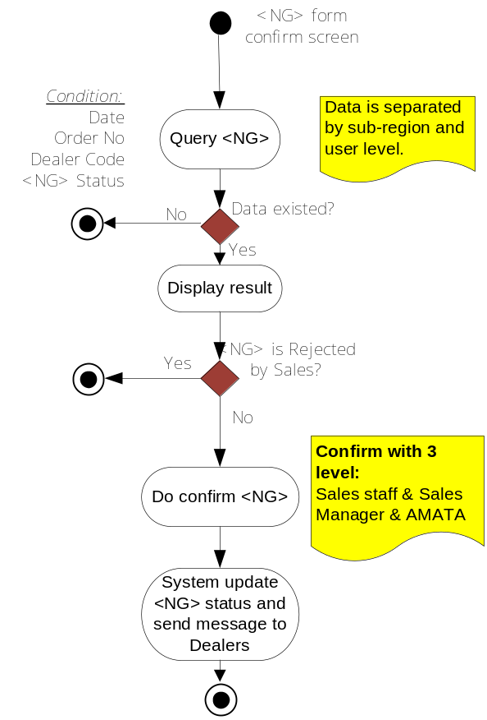
  - Description Requirement:
    - Flow of business:
- Search and display the <NG> form:
- Users select functions <NG> form confirm
- The system displays the screen with search terms.
- Users enter their search terms (date, number , dealer code)
- Do “Search”
- The system displays search results.
- Note: The system will search and display both form for two cases: Abnormal receive and change part
- Users can view details of <NG> form by selecting function <Edit>
- Confirm <NG> Form:
- In search results screen.
- Users select the <NG form> to be confirmed for dealers.
- Cases of confirmation: broken, wrong and lack part, input comment if necessary.
- Do “confirm”
- The system sends the confirm information to dealer.
- After confirm the <NG> form for dealer, system also send a message to dealer to notify dealer know about this.
    - Special requirement:
- Confirm workflow: (1) Sales man confirm → (2) Sales Manager confirm → (3) AMATA confirm
  - When finish confirm send message to next level at home page
  - Sale man confirm NG form by sub-region (from level 2 can confirm for all), if an sale man belong two sub-region then create two account to login
- Reject workflow: (1) AMATA rejects Sales Manager → (2) Sales Manager rejects Sale man → (3) Sales man rejects Dealer (comment is required).
* When reject for only one part in <NG> form → reject for the whole <NG> form.
* Check and confirm <NG> function is set by right permission with user.
* When reject send message to previous low level, if level 1 reject, send message to dealer

NG Form lack tracking
  - Brief description:
- Tracking the lack case only of NG form, system provide the query and maintain the NG form status (solved or not).
- User can maintain the NG lack case status.
- System provide Reward Form print out.

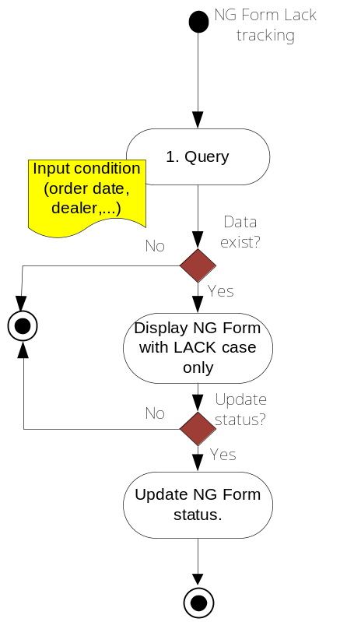
  - Description requirement:
    - Flow of business:
- Search displays a list of NG form which are LACK case only:
  - User select <NG Lack Tracking> function
  - System display < NG Lack Tracking > screen
  - Users enter search terms (OrderDate, OrderNo, NG No, DealerCode, Status).
  - The system displays search results.
- Update NG status:
  - In the screen of search results
  - Users select the desired NG Form to do "Update"
  - Do “Update”: Status (Y/N) and Remark value.
  - The system updates the status of NG form.
    - Special requirement:
- System only query the NG form with LACK case only
- System provide Reward form print out.

Undo “Auto Receive”
  - Brief description:
- Use under special circumstances to serve our Sales Department to restore the automatical import stock operation at dealer side.
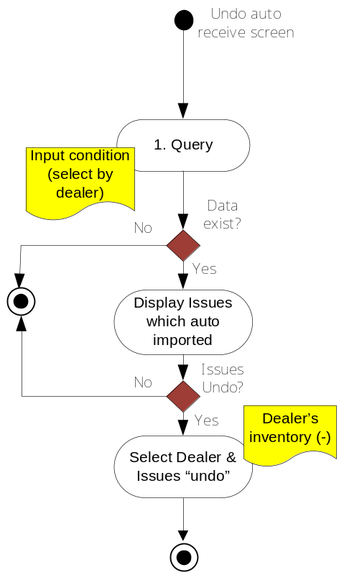
  - Description requirement:
    - Flow of business:
- Search displays a list of orders are import automatically:
  - User select <Undo Auto Receive> function
  - System display <Undo Auto Receive> screen
  - Users enter search terms (imported stock date, dealer code, orders no).
  - The system displays search results.
- Do “Undo”:
  - In the screen of search results
  - Users select the desired order to do "Undo"
  - Do “Undo”.
  - The system updates the inventory number of dealer (minus the inventory), restoring the order into not yet importing stock status.
    - Special requirement:
- With special case, VMEP can undo this “automatically import” action (dealer contact with VMEP), after undo, the system will check in the next 24h, if the time that dealer are still not import, the system automatically re-import the stock again (sales can undo auto receive with no limit times, after 21 days from payment day, no one can undo receive)

Basic Data Setting
  - Description:
- VMEP provide SYM part list and upload into VDMS
- VMEP maintain:
  - Payment span: Days (3 days currently)
  - Receive span: Days - by dealer
  - Shipping span: Days – by dealer (default= 3 days)
  - Undo receive span: default 21 day, all dealer
* (Reserved) Modify receive data span: Days - by dealer (default= 2 days) (After “do in stock”, dealer can only change data in this span time)
  - Quotation span - from order sent to quote (default= 1 day): VMEP must do quote when dealer order in fix time. When expired send warning message to Sale Manager.
  - Part Drawing Spec & Location & Engineering change: Reserved for future use
  - Order Frequency code (A - B - C... class) of ordering part (be reserved)
  - Sub part code; built by Tiptop program (be reserved).
  - Category code: SYM: C (chain), O (oil), P (plug), B (battery), T (tire), S (service). * *Must be used to match “specification code”: E (Engine), F (Frame), D (Electricity – Điện), A (accessory)

Order date control
- System provides an date setting function for each dealer to control their ordering date.
- Set by VMEP managers and separated by south & north area.
- Order date setting rule: set by week
- ex. dealer A : every Mon, Wed, Fri.
- dealer B : every Tue, Thu.
* No need to concern about setting in what year?, in what month?
- Ord-date-set can be modified at any time (system logs modified date).
- Ord-date-set is used only to control dealer's send order function.
* If order send-date is not fallen on the ord-date-set, then system sends out a warning (cannot order !!).
* If certain dealers have not order date setting, then they can order everyday.
* Dealers can do any function on ord-date-set excluding sending order.
* Ord-date-set cannot control orders which is key-in or transferred from Tip-Top (by manual control).
* System doesn't control order qty and order frequency anytime.
* System provides a gate to set open or close "Order Date Control" function.
- Re-Order same part in the next Order and provide a gate to control (on/off)
  - Conclusion: When send order, check all parts in the order which is not include in the list not yet quotation, cannot send.

Reports
- Over Shipping span report:
  - By Payment date
  - Region (south & north)
- Short Order report (for Sub-Order):
  - Can/cannot supply (top *** - top can be input by user) {Part number | quantity} by:
    - Date range
    - Dealer
    - Region
- Part order service management summary (service rate & supply rate):
  - By date range, VMEP (south & north) or dealer
    - Supply rate = ship items/ total items (by part No)
    - Service rate = ship pieces / total pieces (by part quantity)
    - Service rate = sum (shipping qty (original order+sub orders))/sum(order qty(original order only) (19.08.2009 – updated)
- Abnormal receive report (Broken, Wrong, Lack parts): Get data only from level 2 approved
- Warranty return report
*Not including closed Sub-orders or closed NG forms.
*Can export data into excel file
- Dealer's quantity inventory
  - Time is currently
  - Part No
  - Part Name
  - Quantity
- Dealer's sales report (only SYM parts)
  - Date (from, to)
  - Part No
  - Part Name
  - Qty
  - Price

VDMS-I

Bonus plan
  - Brief description
    - Query existing bonus plan.
    - Add new plan
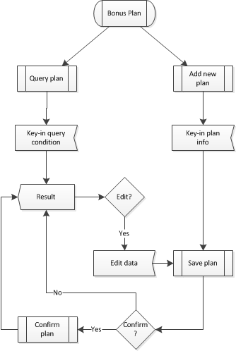
  - Flow of process
    - Query bonus plan:
      - User input Plan name, Dealer code and Plan date (all are optional).
      - Do <Find>
      - System displays the result.
    - Edit a plan
      - The plan must not be confirmed.
      - User click on a Plan which he want to edit and select <Edit>
      - User change desired information.
    - Add new plan
      - On “Bonus Plan” screen, user click <Add new plan>
      - Input Plan name and month (compulsory) and Bonus information for each dealer.
    - Confirm a plan
      - User select a plan and click <Confirm>.
  - Special requirements
    - Available for sale ADM.

Bonus confirm
  - Brief description
    - Get Order data and confirm for bonus status only by sale man.
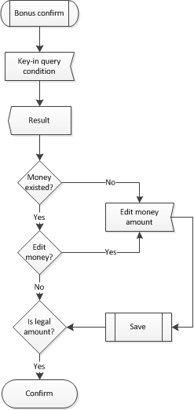
  - Flow of process
    - User key-in query condition to search for orders that they want to confirm.
    - System displays a list of orders.
    - User edits the amount of money in the order they want to confirm if needed and click <Save>
    - User ticks <confirm> and click <save>.
  - Special requirement
    - Available for salemans
    - It is not required for orders to be confirmed before making VDMS orders. If sale ADM syncs 2 order numbers, it will be confirmed automatically.

Bonus monthly close
  - Brief description
    - Sale ADM close bonus in each month to calculate bonus balance
    - Display the current amount of money.
    - Have <close> and <open> link button, which will be reponsible for 2 functions.
    - A plan must be closed before can be opened.
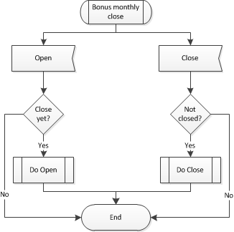
  - Flow of process
    - If a plan hasn’t closed yet, user chose which month to close.
    - If not, user chose either close the next month or open current closed month.
  - Special requirements
    - Available for sale ADM.

Bonus query
  - Brief description
    - Search for bonus plans.
    - Dealers can only see the plans which they participate.
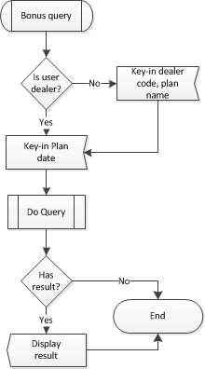
  - Flow of process
    - User key-in plan name, date and dealer code.
    - If user is a dealer, he only has to fill the plan date field. Dealer code is automatically filled and cannot be modified.
    - If there is any result, system will display it, including the amount of money given for each dealer, the amount received and the balance.

Import payment data
  - Brief description
    - FIN import payment data by upload an excel file or input data manually.
    - If use an excel file, user must choose appropriate excel format for each bank.
    - Importing payments will be previewed before saving.
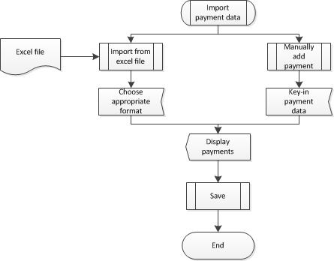
  - Flow of process
    - If FIN want to upload excel file, select <browse> button to choose an excel file.
    - Choose excel format in <Bank> field.
    - Click <upload>
    - If FIN input data manually, fill all fields and click <add new payment>
    - Preview payments.
    - Click <save>. Ortherwise, choose <Clear data>.
  - Special requirements
    - If bank excel format is not correct, payments canbot be added. It can be corrected in VMEP Settings > System parameters > Payment excel file.
    - Specialized for FIN

Query payment data
  - Brief description
    - Used for review payment data before re-cosign.
    - Summary payments from dealer.
    - Allow FIN editing payment.
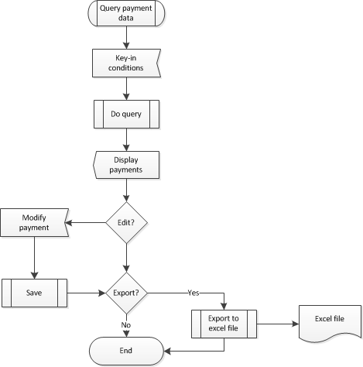
  - Flow of process
    - User key-in query conditions: Order number, dealer code, Payment date, Status (all are optional).
    - System does query and displays result.
    - If user want to edit a payment, click pencil icon.
    - If user want to export data to excel file, click <Export excel>.
  - Special requirements
    - Specialized for FIN.
    - User can only edit a payment which is not confirmed.

Do re-consign
  - Brief description
    - Re-calculate payment amount for orders.
    - Payment amount = Bonus amount + Bank payment amount.
    - If payment amount greater than Order Amount: Separate the payment amount to 2 parts:
      - Equal to Order payment amount
      - Remaining amount (may be used for next orders, has remark)
    - In case payment amount less than Order Amount: high-light the Orders and the allow VMEP’s FIN change the Payment data with these fields: Description and the TIPTOP voucher (more details in FIN confirm payment)
  - Process of flow
    - User choose query conditions: Dealer code and Payment date to search for payments.
    - Click <Re Consign> to do re-consign.

Confirm payment
  - Brief description
    - Mark payment(s) as confirmed.
    - Has Check selection, default value is: YES if payment amount equal to or greater than Order Amount. Otherwise NO.
      - Confirm one button (by rows)
      - Confirm All button
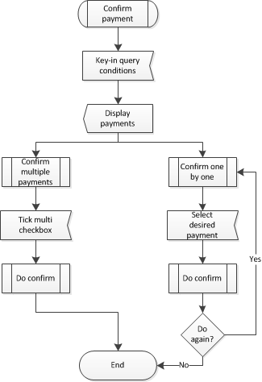
  - Flow of process
    - User key-in quey conditions: Area, Dealer code, Order date, Order number and Status. Click <Find>
    - User can confirm by either one by one or multiple payments.
      - One by one: Select desired payment, enter Tiptop voucher and Description if needed and click <Confirm>
      - Multiple: Tick a checkbox next to each payment or select one of following options: All, Fully paid, Partly paid, Unpaid and None. Then click <Confirm selected>

Lot sale to end-customer
  - Brief description
    - Sale multiple vehicles at once.
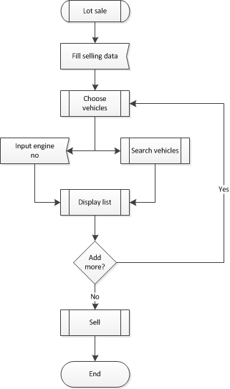
  - Flow of process
    - User fill in selling data: Sell date, Choose customer, Bill No…
    - Can choose vehicles by 2 ways:
      - Input engine number directly: a vehicle having that engine number must be currently in the departure.
      - Use vehicle searching function. User can search by following criterias: Vehicle type, Color, Engine number. Check the checkbox to mark a vehicle as transfering.
    - After adding a list of vehicles, user key in a price of each vehicle.
    - Sell vehicles.
  - Special requirements
    - Can be used only be ADMINISTRATOR group.

Stock transfer
  - Brief description
    - Transfer multiple vehicles within branches belonging to the same dealer.
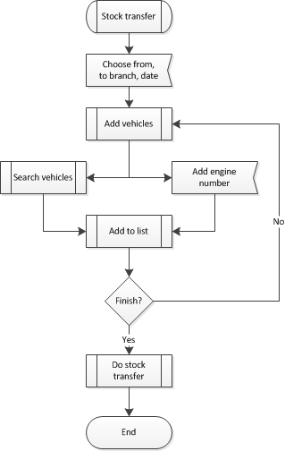
  - Flow of process
    - User choose destination, departure and transfer date.
    - Add vehicles to list
      - Input engine number directly: a vehicle having that engine number must be currently in the departure. Add to list by clicking <+>
      - Use vehicle searching function by clicking <Search vehicles>. User can search by following criterias: Vehicle type, Color, Engine number. Check the checkbox to mark a vehicle as transfering.
    - If there is no errors, proceed to do transfer.

Import Sale Data from Excel
  - Brief description
    - Dealers import sale data weekly or monthly.
    - The excel format must be specified.
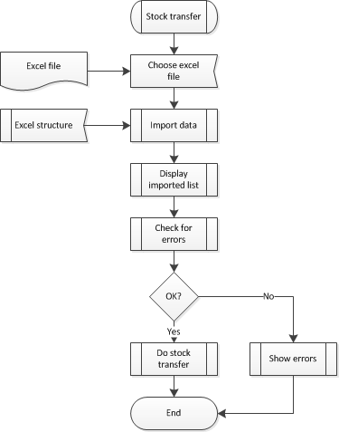
  - Flow of process
    - User browses an excel file to import.
    - System will try to import data from that file. If no errors occurred, display a list containing all selling data. Otherwise, display an error.
    - User click <Import>.
    - All of selling data must be correct. If not (one of them has errors), the importing process fails.
  - Special requirements
    - User must specify excel format in Homepage > Basic Data Setting > VMEP Setting > System parameters.

Lookup Warranty Parts
  - Brief desciption
    - User can view a list of parts that in warranty condition.
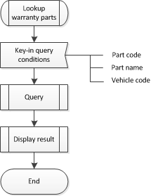
  - Flow of process
    - User key-in query conditions: Part code, part name, vehicle code.
      - If there is no conditions, system will display all parts.
      - Otherwise, the result will based on those conditions.

